**CASE STUDY**

**MODULE 5**

**VPC**

**DEVELOPMENT NETWORK**

**DONE BY**

**RANJITH KUMAR**

**Development Network:**

1. Design and build 2-tier architecture with two subnets named web and db

and launch instances in both subnets and name them as per the subnet

names.

2. Make sure only the web subnet can send internet requests.

3. Create peering connection between production network and development

network.

4. Setup connection between db subnets of both production network and

development network respectively.

STEP 1 : Open VPC from aws services

STEP 2 : Go to VPC > Subnet > Create Subnet

STEP 3 : Create route table for the db and web subnet

STEP 4 : Associate subnets to the route table(Public ,Private)

STEP 5 : Create a internet gateway to allow communication between vpc and internet

STEP 7 : Attached the internet gateway in the routetable

STEP 8 : Create 2 instances running in the development VPC and subnet .

STEP 9 : Select Peering connections

STEP 10 : Create a peer between production and development vpc to route traffic between them

STEP 11 : Now edit the routes of the db subnets route table in production network to route traffic between production & development network subnets . Add the destination of the development db subnet is it and add the peering connection.

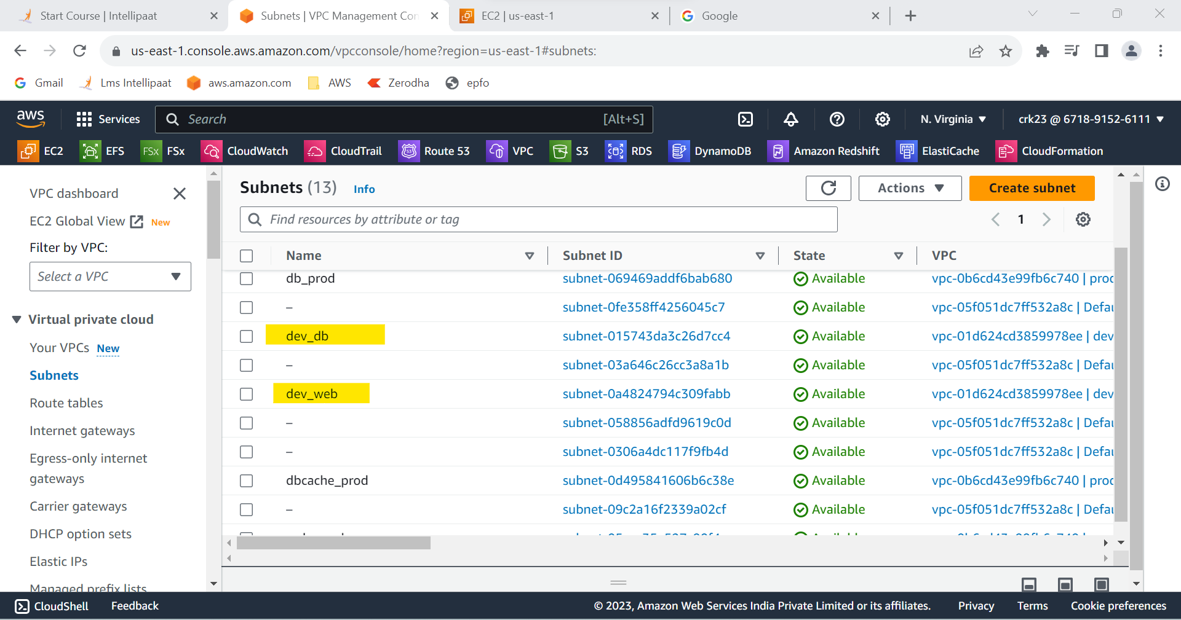

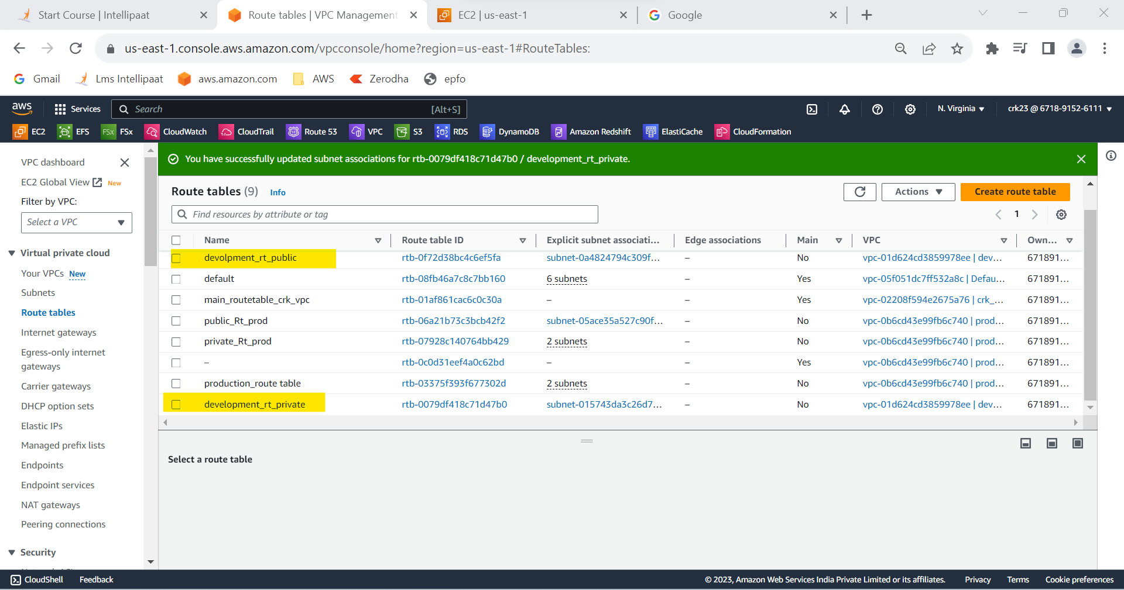

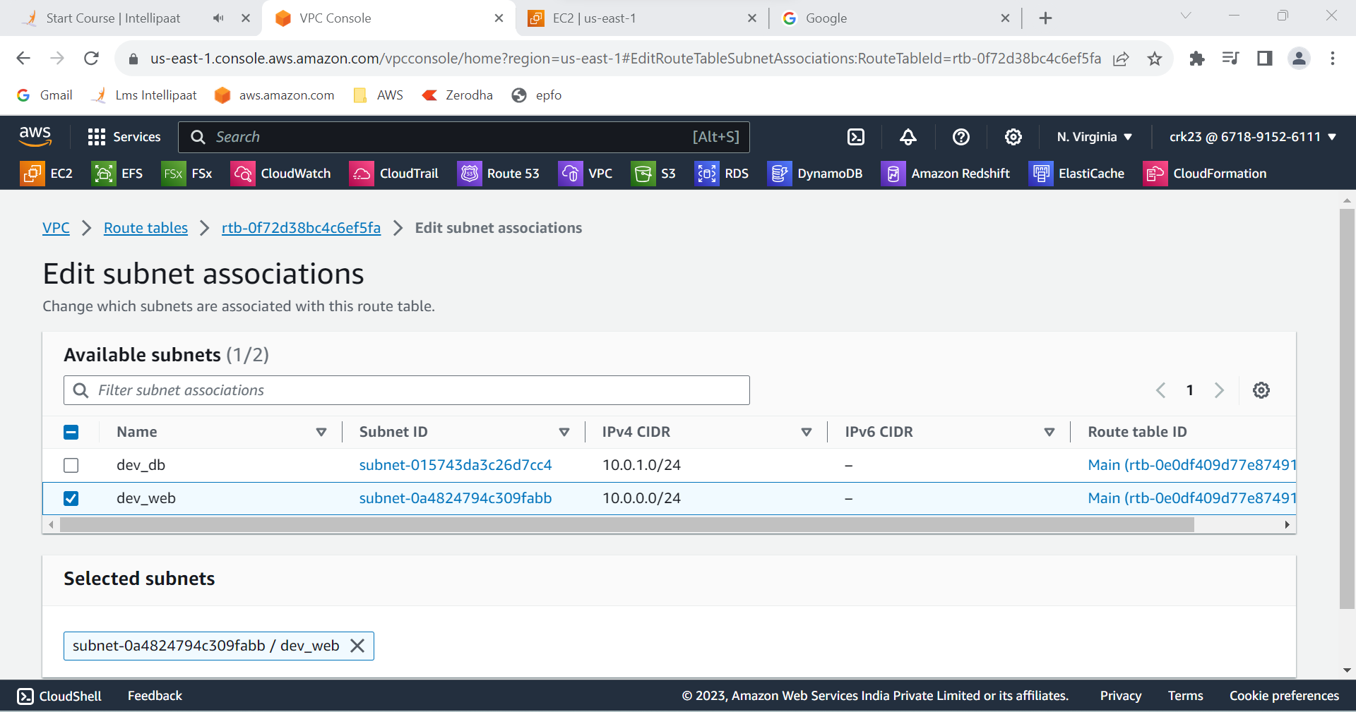

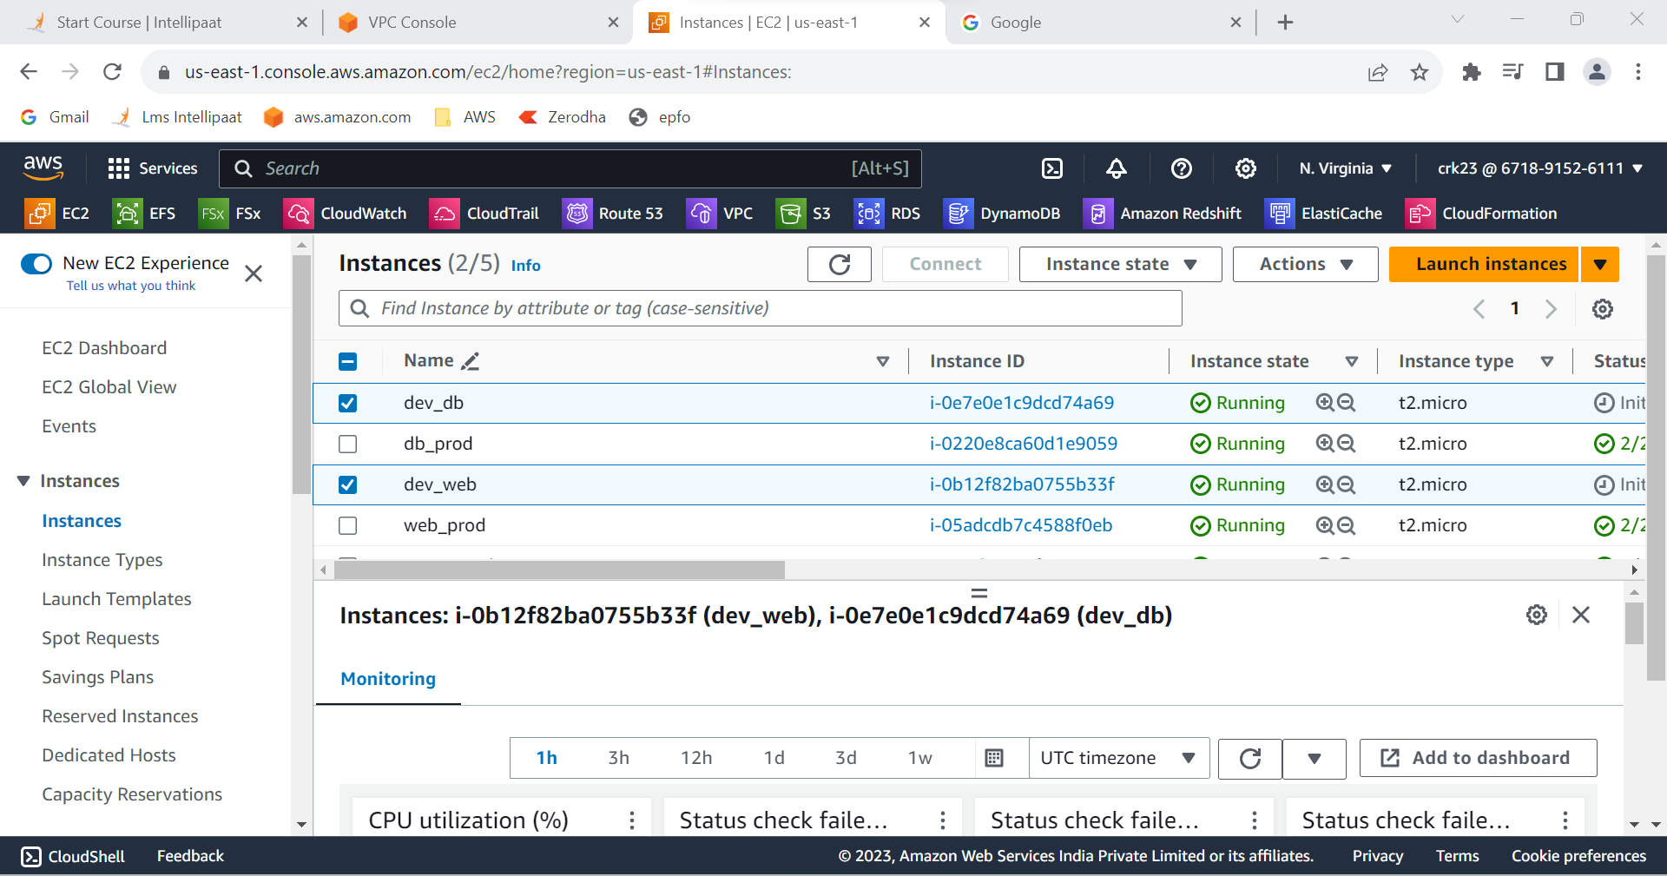

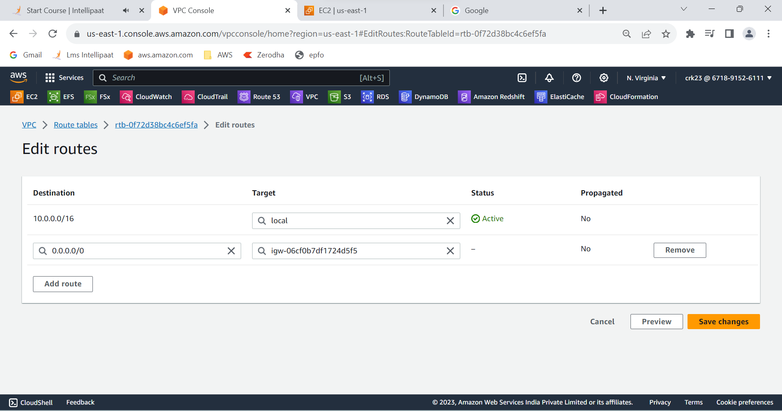

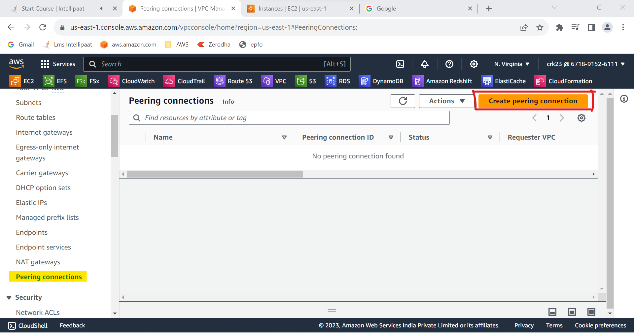

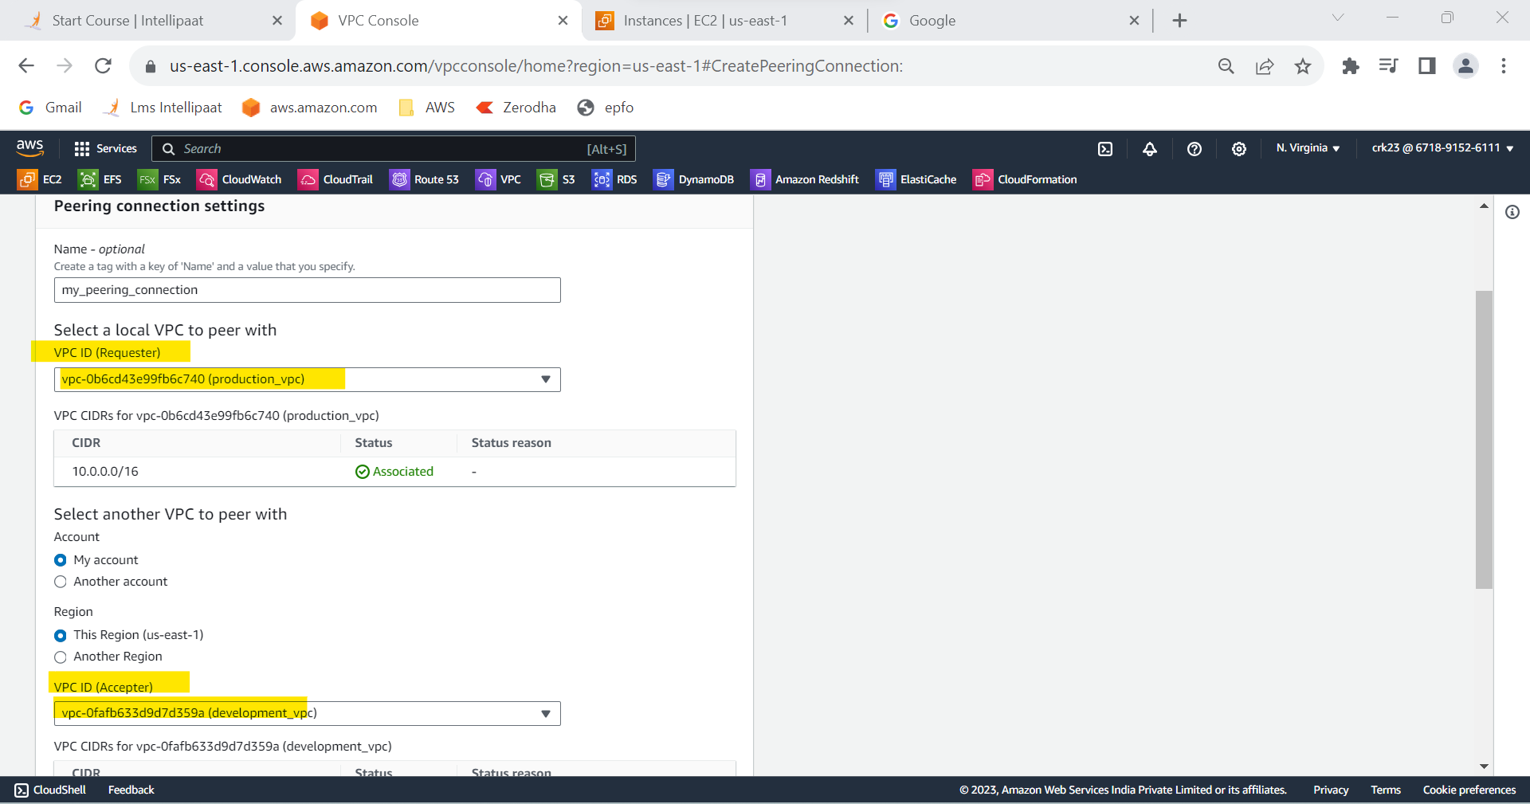

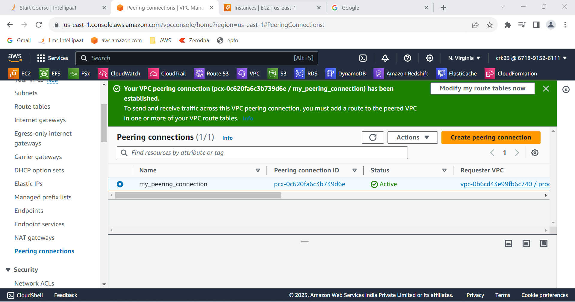

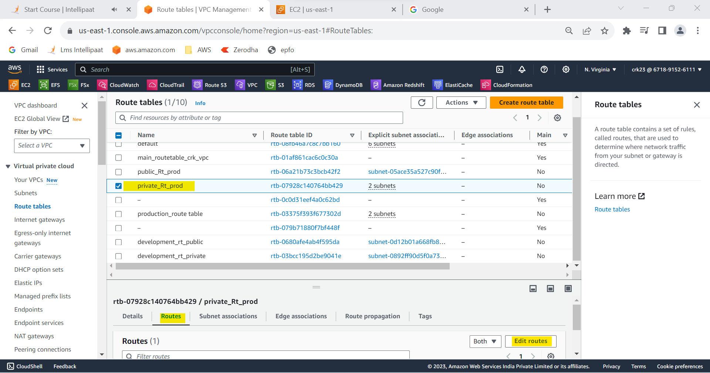

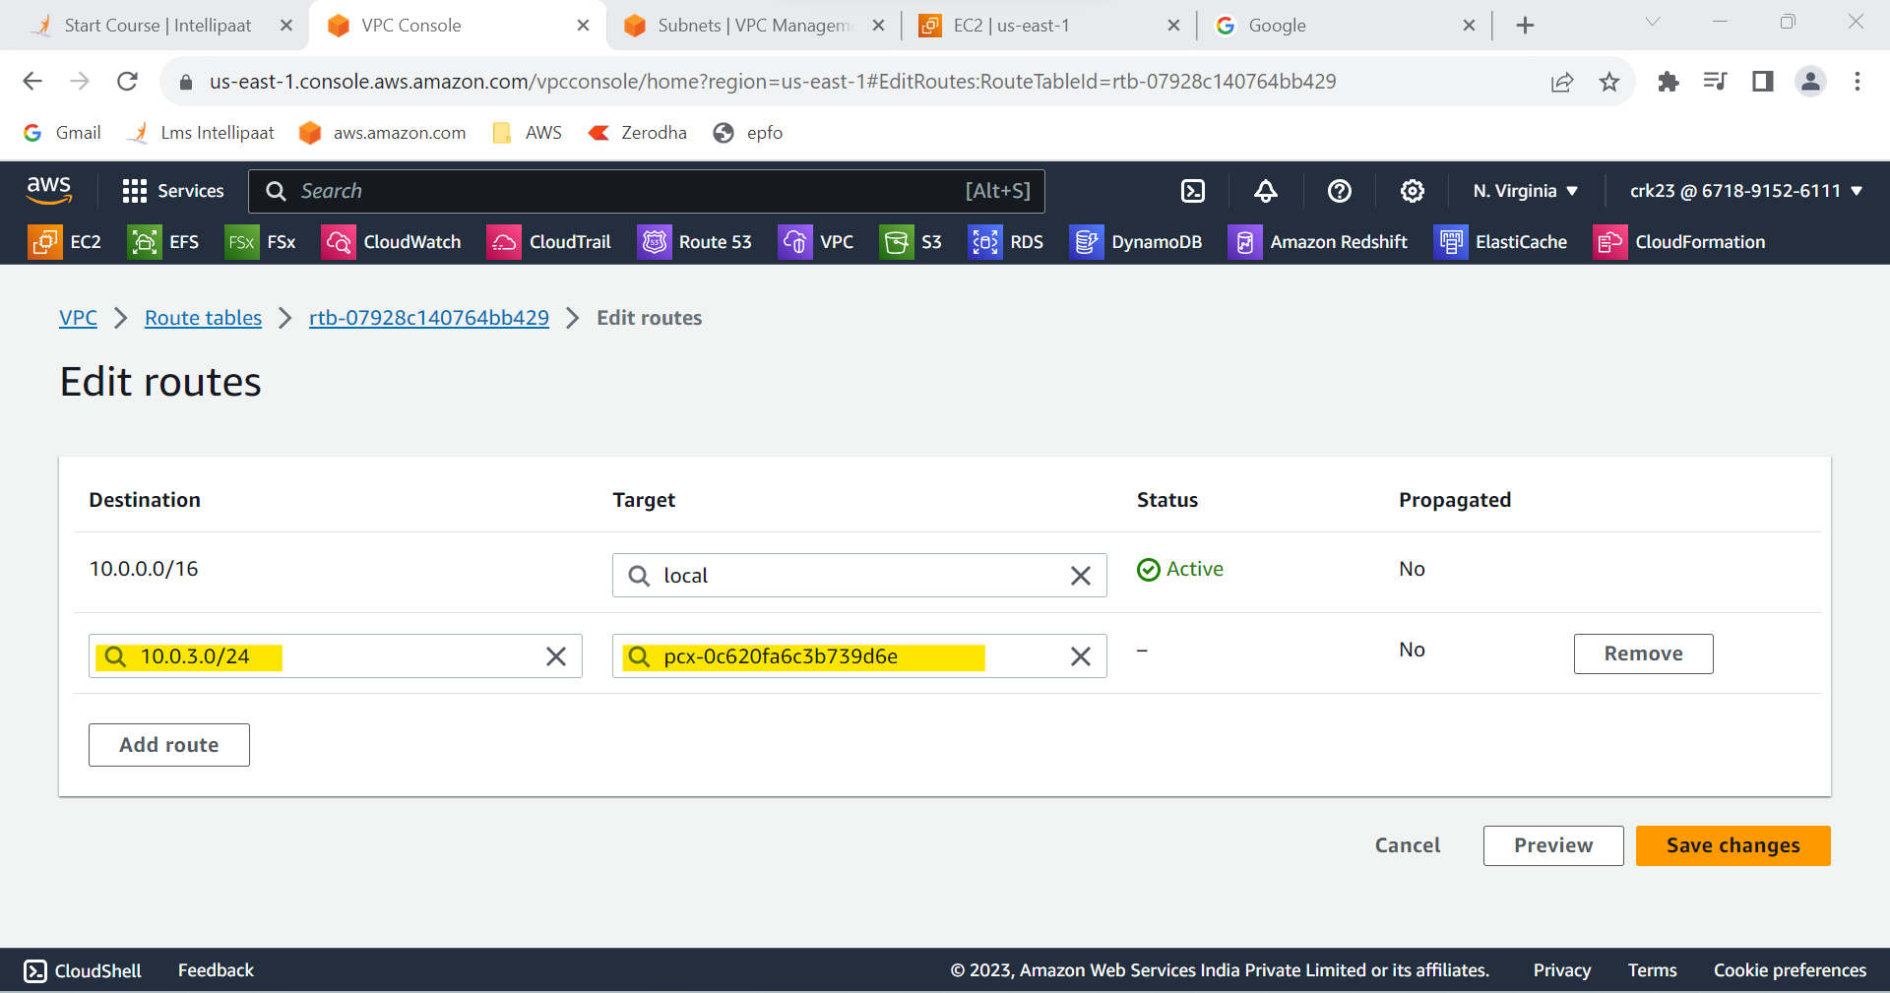

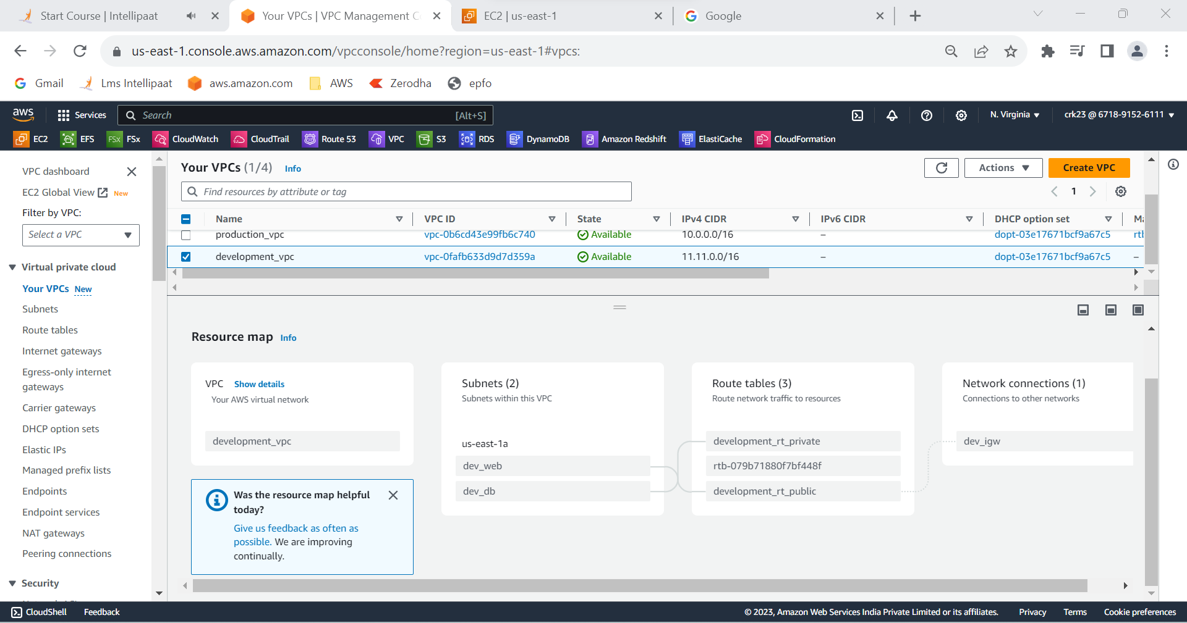

**OUTPUT:**

Created subnets named web and db and launched instances in both subnets and name them as per the subnet names.And added internet gateway to web subnet to send internet requests.Created a peering connection between production network and development network.Created a connection between db subnets of both production network and development network.